**KWAME NKRUMAH UNIVERSITY OF SCIENCE AND TECHNOLOGY**

COLLEGE OF SCIENCE

DEPARTMENT OF COMPUTER SCIENCE

# 



**MINI PROJECT DOCUMENTATION**

**PROJECT TOPIC**

Online Shopping System

**STUDENT NAME**: Mensah Richmond Gyau Baffour

**STUDENT’S INDEX**: 4615518

**PROJECT SUPERVISOR**: Dr. Frimpong Twum

**CONTENTS**

CHAPTER 1 - INTRODUCTION

1.0 - Background

1.1 - Problem statement

1.2 - Aim of Project

1.3 - Specific Objectives

1.4 - Project Scope

1.5 - Project Justification

1.6 - Project motivation

1.7 - Project Beneficiaries

CHAPTER 2 - REVIEW OF RELATED WORKS

2.0 - Review of related systems

2.1 - Overview of System 1

2.1.1 - Good features

.

.

.

2.1.2 - Bad features

.

.

.

2.2 - Overview of System 2

2.2.1 - Good features

.

.

.

2.2.2 - Bad features

.

.

.

2.3 - Overview of System 3

2.3.1 - Good features

.

.

.

2.3.2 - Bad features

.

.

.

CHAPTER 3 - METHODOLOGY

3.0 - Overview of the Proposed System

3.1 - Project method adopted and justification

3.2 - Requirements specification

3.2.1 - Functional requirements of the system

3.2.1.1 - UML models

3.2.2 - Non-Functional requirements of the system

3.3 - Architectural Design of the Proposed System

3.3.1 - Components Design

3.3.1.1 - Database Design

3.3.1.2 - User interface Design

CHAPTER 4 - IMPLEMENTATION AND TESTING

4.0 - Development Tools and Platforms consideration

4.1 Mapping logical design onto physical platforms

4.2. - Database schema

4.3 - User interfaces

4.4 - Testing

4.4.1 - Units/Components testing

4.4.2 - Integration and System testing

4.4.3 - Deployment model and platforms

4.4.4 - Acceptance Testing

CHAPTER 5 - CONCLUSIONS AND RECOMMENDATIONS

5.0 - Discussions

5.1 - Achievements

5.2 - Conclusions

5.4 - Recommendations

5.5 - References

**CHAPTER ONE**

INTRODUCTION

This chapter presents the background, problem statement, aim of project, specific objectives, project scope, project justification, project motivation and project beneficiaries.

1.0 BACKGROUND TO THE STUDY

Ghana is a developing country and Information Communication and Technology are playing their important roles in the development of the country. By eCommerce, we mean buying and selling of products or services over electronic systems such as the internet and other computer networks. In truth in Ghana, we have very fewer ways to pay our bills online or trade online but that does not mean we cannot. There are new players on Ghanaian ground like momo and tingg who want to revolutionize the way Ghanaian eCommerce field is taken. With the launch of these services, many startups can easily sell their products and services online. E-commerce is fast gaining ground as an accepted and used business paradigm. More and more business houses are implementing websites providing functionality for performing commercial transactions over the web. It is reasonable to say that the process of shopping on the web is becoming a commonplace.

* 1. PROBLEM STATEMENT

For all the burgeoning and accessibility of a wide range of web applications, creating a user-friendly and high-performing web application is a difficult task. If the time limit is particularly short, web application development can be wide open to threats and mistakes due to its time-consuming nature. There is a creative disconnect between the number of problems and the number of people with the necessary talents. Also, people with acquired talents spend the majority of their time working on a single project, despite the fact that there are numerous problems to fix. In web application development, creativity is a fundamental instrument for resolving difficulties of various dimensions.

* 1. AIM OF PROJECT

The main purpose of this application is to provide our clients with convenient service, accessibility, and quick delivery of products. The application is designed to free individuals from service restrictions imposed by a certain geographic location. The program has been designed in such a way that it is user-friendly for its users.

1.3 SPECIFIC OBJECTIVES

* Easy application with user friendly features

* This program will function as a guide, providing a diversity of options from which to choose to prevent time consuming.

* Handling orders with more accuracy and increase their productivity.

1.4 PROJECT SCOPE

This program is designed to give basic reciprocal functionality, with a good colour scheme and images. The application's mobility is very adaptable, allowing for quick access to fundamental commands. Response time for a specific action is crucial when it comes to technology. This program ensures that a task is completed as efficiently as possible. With a customized navigation page, this application gives many alternatives for ordering various types of jewellery.

1.5 PROJECT JUSTIFICATION

Customers are more likely to buy if you give them a variety of options to choose from, according to research. But the key question is; What value can you supply that makes your application more effective and efficient? The proper content has been employed to assure the application's effectiveness and efficiency.

1.6 PROJECT MOTIVATION

As a developer your major priority is to be a content creator of which

your work will impact lives. Adding jewellery to your outfit makes you look stunning but where to get quality jewellery and selection of jewellery is a major challenge. This application is set to guide you in selection of quality jewellery which costs less.

1.7 PROJECT BENEFICIARIES

* Customers
* Delivery agent
* seller

**CHAPTER TWO**

2.0 This chapter talks about the review of related systems.

2.1 **Overview of KiKUU online shopping app**

KiKUU is an african online shopping mall with 400000 latest fashion products available in the app. Vary from fashion products to life essentials , you can enjoy massive deals everyday. Over 2 million people in africa use KiKUU to shop affordable goods. Including Ghana, Tanzania, Cameroon, Uganda, Dr COngo, Senegal, Rwanda.

2.1.1 **Good features**

* Customer service is perfect.
* Good and affordable prices

2.1.2 **Bad features**

* Late deliveries
* Lack of trust and user resistance

2.2 **Overview of JUMIA online shopping**

JUMIA is the largest online retailer in africa. From fashion to electronics, find everything you need on africa’s largest online shopping store. Payment is made easy with secure payment option including cash on delivery, mobile money or pay using your credit card with our secure payment portal, Jumia Pay.

2.2.1 **Good features**

* Quality goods
* Variety of goods to choose from

2.2.2 **Bad features**

* Costly shipping fee
* Money refund can be complicated

2.3 **Overview of Ubuy Online App**

Ubuy is a one stop online shopping app to all the shoppers who’re in continues search for interesting , new and unique products. You have the option to choose your store, like you can get the products from the US, UK, China and Kuwait store.

2.3.1 **Good features**

* Good prices
* Fast delivery

2.3.2 **Bad features**

* High shipping charges
* No cash on delivery.

**CHAPTER THREE**

3.0 Overview of Proposed System

This system involves its own database to be maintained. As the information or details about the products are stored in the database for the server-side functionalities. The Server process is for dealing with the customer’s detail and the items that are shipped to different locations based on the addresses provided by the customers.

The application design contains two modules one is for the customers who wish to buy the articles. And another is for the store owners who maintain and updates the information regarding the articles and about the customers. The end-user to use this product are the common people for whom the application is to be hosted on the web and the admin maintains the database.

The application that is deployed on the customer’s database like RDBMS, the information regarding the items is highlighted and forwarded from the database for the customer (front view) based on the choice through the menu list and based on all these searches and transactions the database of all the products is updated at the end of each transaction.

The entries for products, into the application, can be made through various screens designed for various levels of users. As soon as, the authorized personnel feeds the relevant data into the system, several reports are generated based on the security policy used.

This system is a web based application made of HTML,CSS,JAVA SCRIPT,AND NODE JS.

3.1 Project Method Adopted and Justification

This system was purely built on web based skills which has been acquired to help solve problem using the internet.The work focuses on applying specific knowledge or skills ,which involves much works to improve motivation in order to foster independent thinking,self-confident and social responsibility.

All products in the system are shown in a compact and easy-to-read manner within this application, together with their accompanying options and delivery details. This helps shop personnel to quickly review orders as they come in and supply the relevant items with minutest delay.

After making a decision, the item is added to the customer's cart, which they can review at any time before checking out. This gives you fast visual evidence of what you selected and guarantee that the products in your order are exactly what you wanted.

The system purposefully lessens the workload for the shop because the entire order-taking method is automated. Once an order is placed on the website, it is entered into a database and then retrieved by the specific personnel of the shop’s end in near real time.

3.2 Requirements Specification

The system is button down into three key parts.The first section of this system is the is the menu management which can allow the shop to control what can be ordered by the customer.The web ordering system is the second second, and it allows customer to place orders and give all relevant information online. The final section is the order extraction, this part takes care of retrieving and showing order information, as well as updating orders which have already been processed.

3.2.1 Functional Requirements of the system

1. Card with pictures, names and prices of products.
2. Single page which shows a little description of product and number of products ordered.
3. Authentication page for keeping track of customers.
4. Cart page where purchases are confirmed.

3.2.1.1 UML model

CUSTOMER SHOP ATTENDANT

PRODUCTS

ORDER RETTRIEVAL

DATABASE

WEB ORDERING

3.2.2 Non-functional requirement Of the The System

1. **Usability**

* A web browser
* Stable internet connection

1. **Security:**

* authentication
* user information safe in mongodb cloud database.

1. **Performance:**

* Initial load takes about 5 seconds.
* All other activities are quite fast.

1. **Maintainability**

* Because we are looking to grow, the website shall remove all the back-end complexities for in-house engineers to make changes to the system in the future.

1. **Scalability**

* Our main goal for the next two years is internationalization, so the website shall have multiple storeviews for each country we’re selling to.
* The store shall expand to support 500k+ SKUs on a single server without negative impact on the website load speed.

**CHAPTER FOUR**

IMPLEMENTATION AND TESTING

4.0 Development tools and Platform consideration

* Html
* Javascript
* Visual studio code
* mongoDB
* Node js

4.2 Database Schema

Database Schema

--------------------------------------------------------------------------------------------------------------------------

user = { | product = { | checkout = {

email:String, | name:String, | userId:String,

telepone:String, | type:String, | order:Array,

password:String | brand:String, | totalPrice:Number

} | imgSrc:String, | }

| price:Number, |

| quantity:Number, |

| details:String |

| } |

4.3 User Interfaces

Fig 1.0 Home page

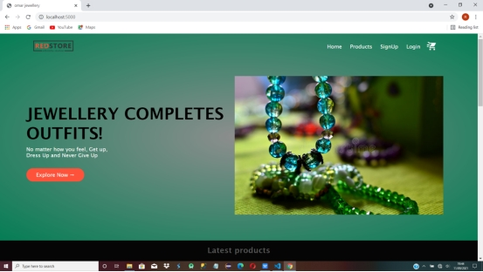

Fig 2.0 Products: Card with pictures, names and prices of products.

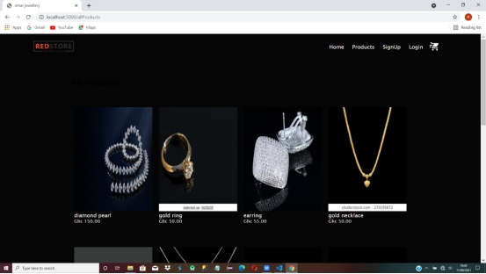

Fig 3.0 Single page which shows a little description of product and number of products ordered.

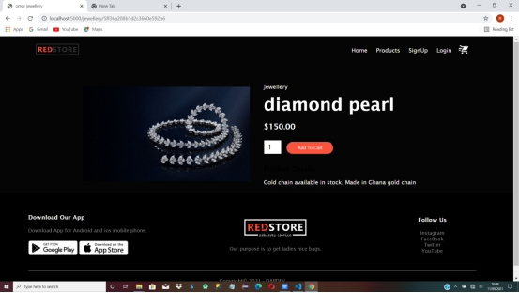

Fig 4.0 and 4.1 Authentication page for keeping track of customers.

Sign up

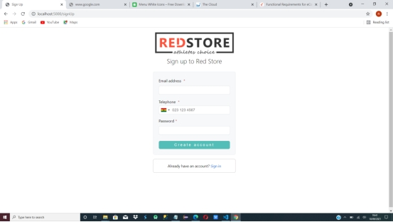

Sign in

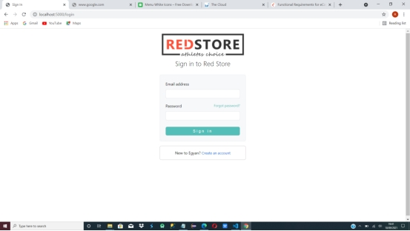

Fig 5.0 Cart page where purchases are confirmed.

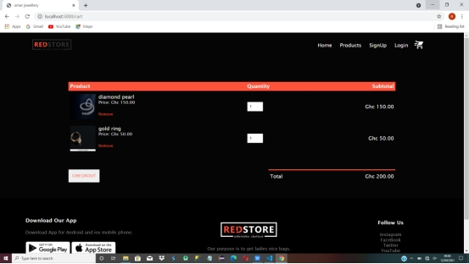

4.4 Testing

Testing usually forms an important aspect of software development process. It checks to see if the system provides the right output when given a specific input. It offers the developer the opportunity of finding errors and to determine if the requirements have been met.

4.4.1 Unit/Components Testing

All individual modules of the system were separately tested to locate and fix errors before integrating.

4.4.2 System Testing

After integrating all modules of the system, the whole system was tested with test data to determine if the modules could function as required.

**CHAPTER FIVE**

* 1. Achievements

The achievements of this project are as follows:

* Users do not have to worry about finding quality jewellery again.
* Many fashion institutions are recommending the application for many people.

* 1. Conclusion

Technology has made significant progress over the years to provide consumers a better online shopping experience and will continue to do so for years to come. With the rapid growth of products and brands, people have speculated that online shopping will overtake in-store shopping. While this has been the case in some areas, there is still demand for brick and mortar stores in market areas where the consumer feels more comfortable seeing and touching the product being bought. However, the availability of online shopping has produced a more educated consumer that can shop around with relative ease without having to spend a large amount of time. In exchange, online shopping has opened up doors to many small retailers that would never be in business if they had to incur the high cost of owning a brick and mortar store. At the end, it has been a win-win situation for both consumer and sellers.

5.4 Recommendation

I highly recommend this web application for everybody, especially those into fashion.

5.5 References

### **Get Rich Click: The Ultimate Guide to Making Money on the Internet.**

### **Growth Hacker Marketing.**

### **DotCom Secrets by Russell Brenson.**